**Lab 10: Configuring and Verifying Standard ACLs**

**Course Code - Course Name:** - COMP4039 – Network Foundations

**Program:** T433 - Cybersecurity

**Section:** A

**Term:** - Winter 2024

**Group Number:** 06

**Student Names - ID:**

* Prabhjot Singh Sains – 101495218
* Rahul Patel - 101378458
* Jai Deep Rawat - 101503760
* M. Salmaan Mustafa Shah – 10151007

**Lab Report by -** Prabhjot Singh Sains

**Topology**

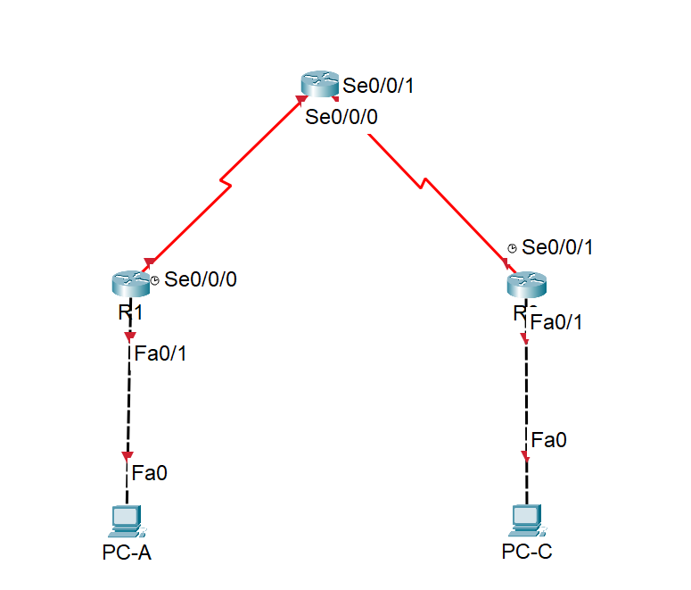

**Addressing Table**

|  |  |  |  |  |
| --- | --- | --- | --- | --- |
| **Device** | **Interface** | **IP Address** | **Subnet Mask** | **Default Gateway** |
| R1 | F0/1 | 192.168.10.1 | 255.255.255.0 | N/A |
| Lo0 | 192.168.20.1 | 255.255.255.0 | N/A |
| S0/0/0 (DCE) | 10.1.1.1 | 255.255.255.252 | N/A |
| ISP | S0/0/0 | 10.1.1.2 | 255.255.255.252 | N/A |
| S0/0/1 (DCE) | 10.2.2.2 | 255.255.255.252 | N/A |
| Lo0 | 209.165.200.225 | 255.255.255.224 | N/A |
| R3 | F0/1 | 192.168.30.1 | 255.255.255.0 | N/A |
| Lo0 | 192.168.40.1 | 255.255.255.0 | N/A |
| S0/0/1 | 10.2.2.1 | 255.255.255.252 | N/A |
| PC-A | NIC | 192.168.10.3 | 255.255.255.0 | 192.168.10.1 |
| PC-C | NIC | 192.168.30.3 | 255.255.255.0 | 192.168.30.1 |

**Instructions**

1. **Set Up the Topology**.
   1. **Configure IP addresses on PC-A and PC-C.**

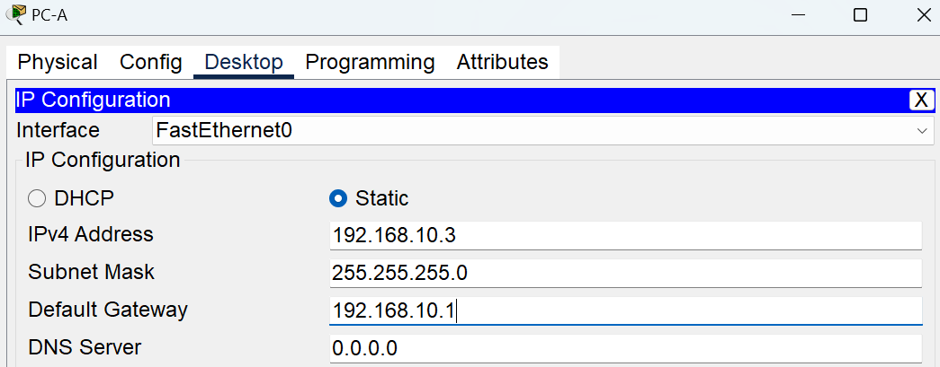

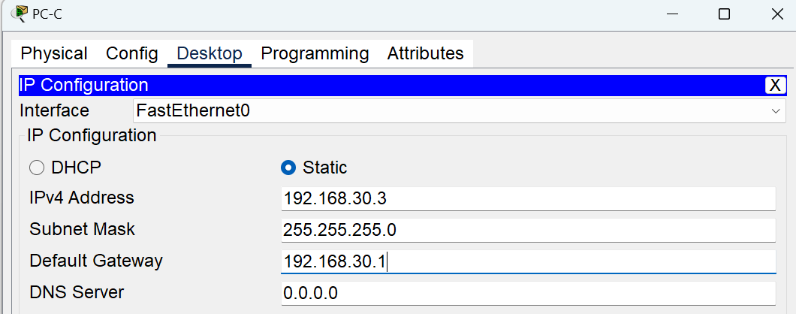

* 1. **Configure basic settings for the routers.**

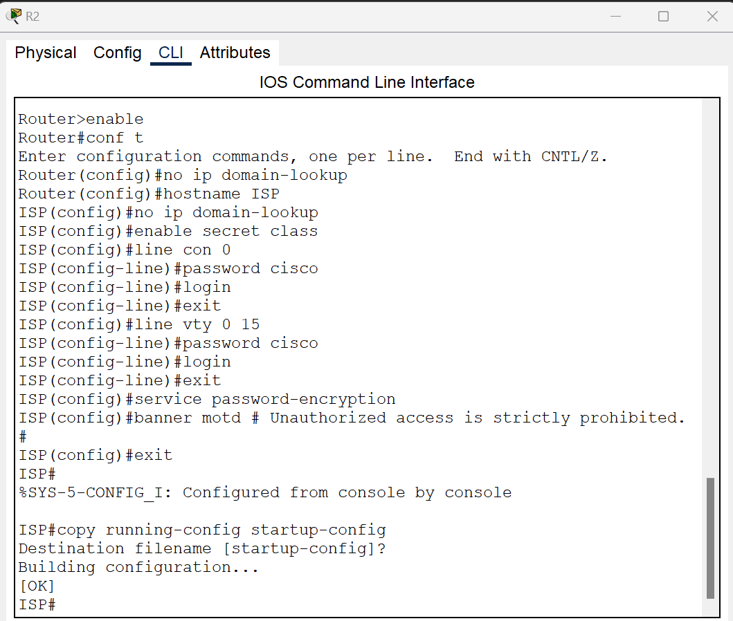

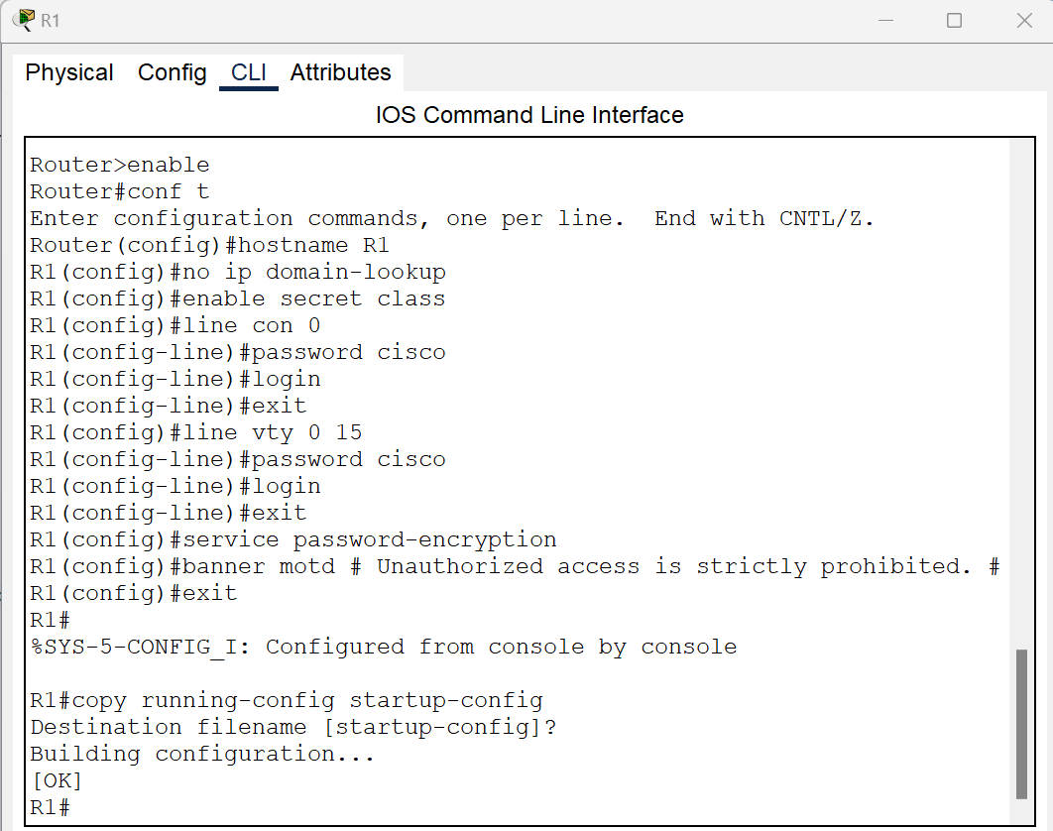

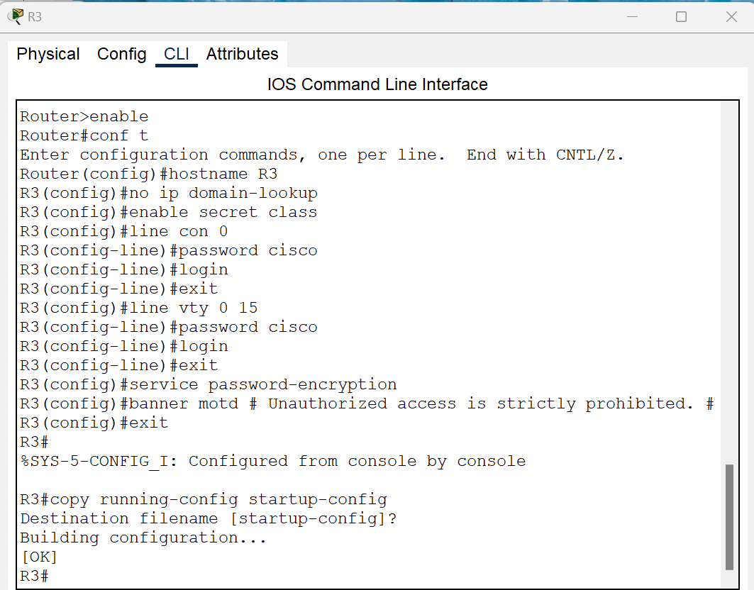

* 1. **Create loopback interfaces on each router and assign the IP addresses to all interfaces as shown in the Topology and Addressing Table (clock rate of 128000 to the DCE serial interfaces).**

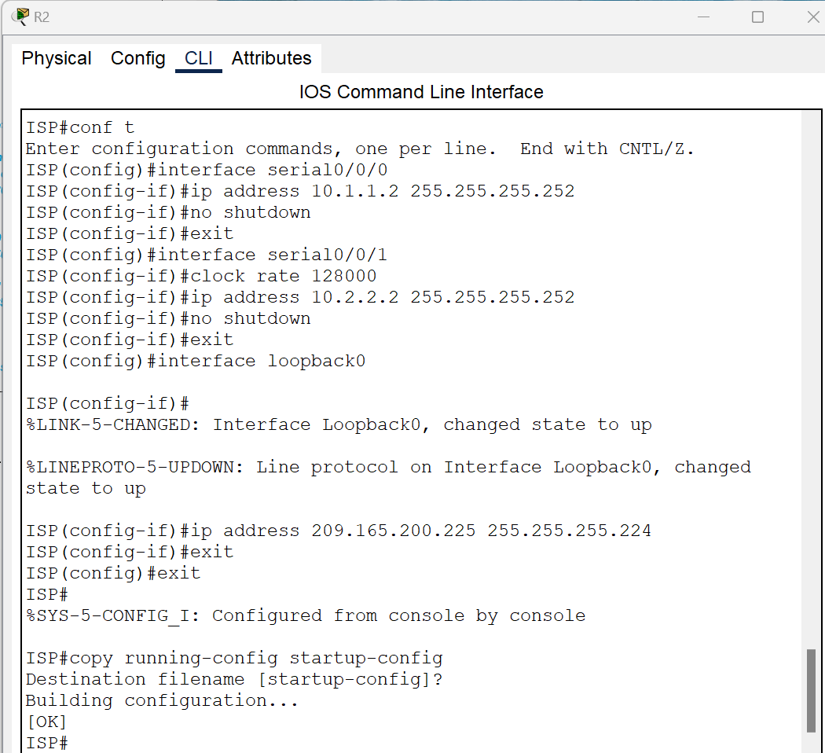

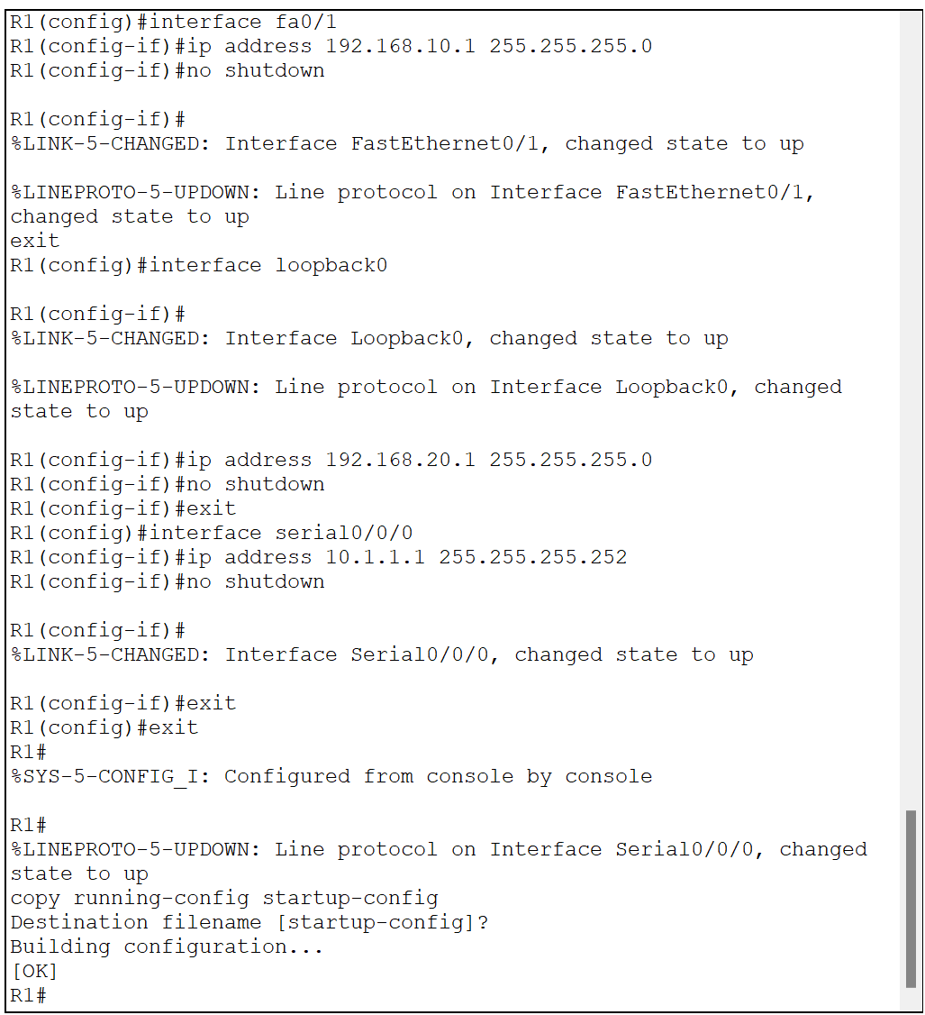

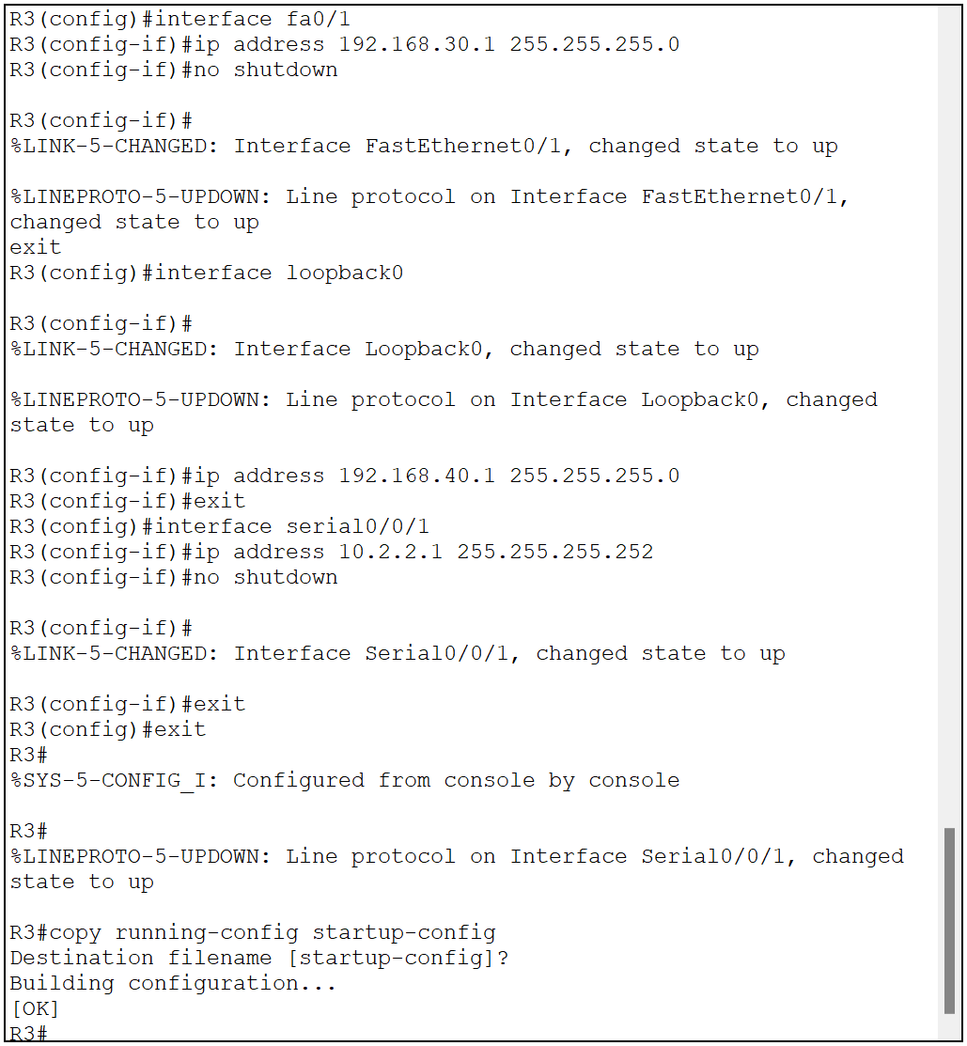

1. **Configure dynamic routing protocol on R1, R2, and R3.**
   1. **Implement any of the classless routing protocols you have learned on all routers (RIPv2, OSPF, or EIGRP).**

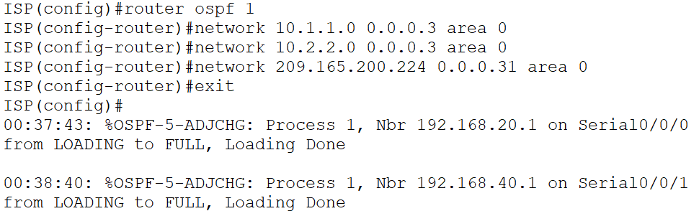

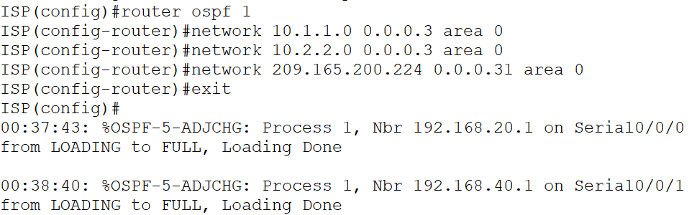

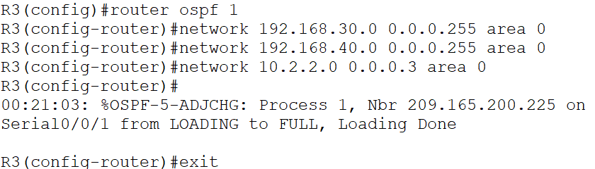

* 1. **Verify that all routers have complete routing tables listing all networks.**

**ISP**

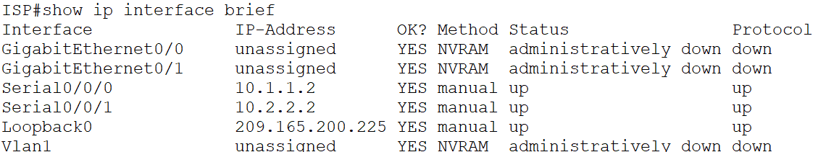

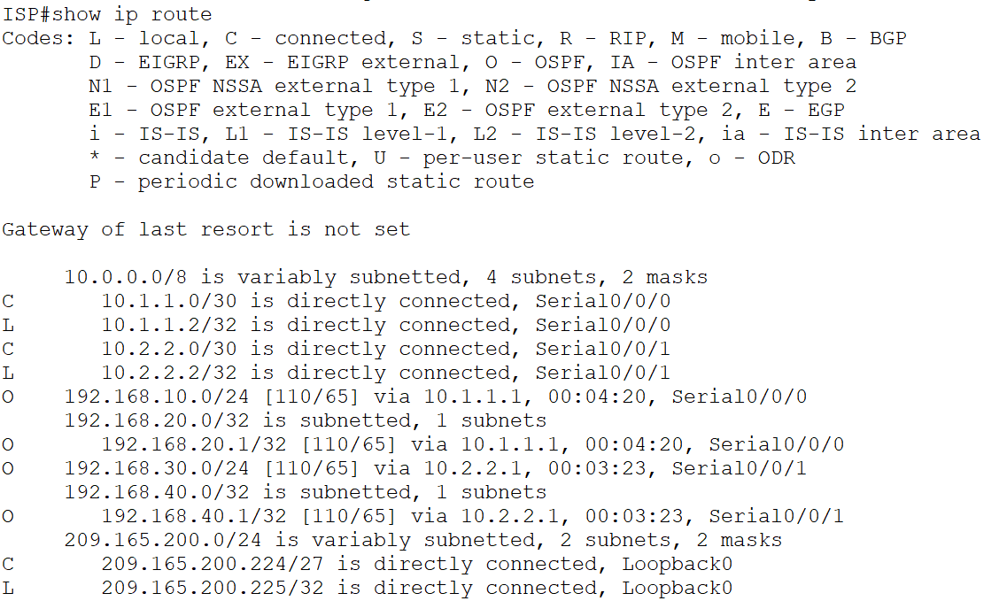

**R1**

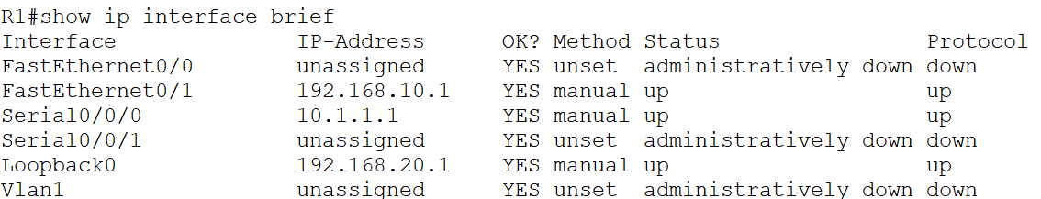

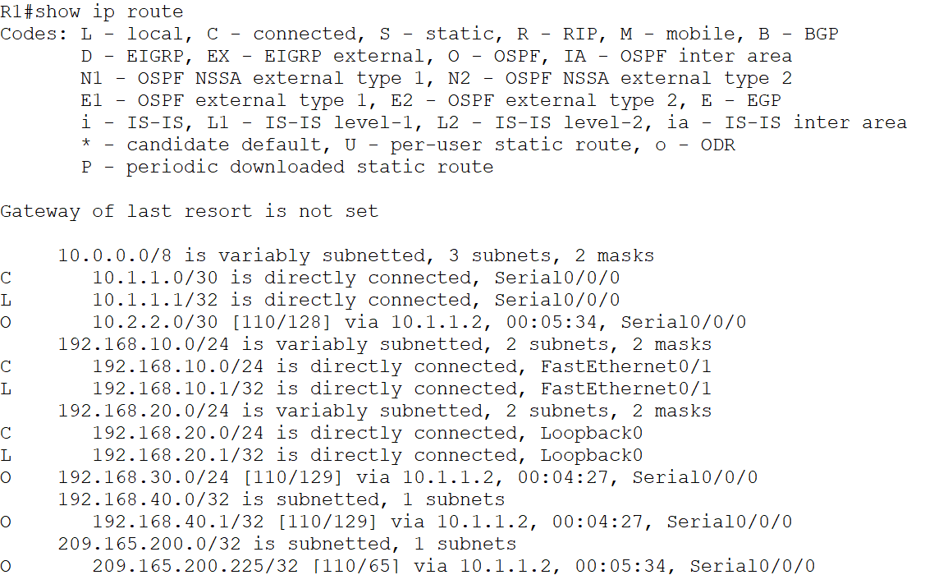

**R3**

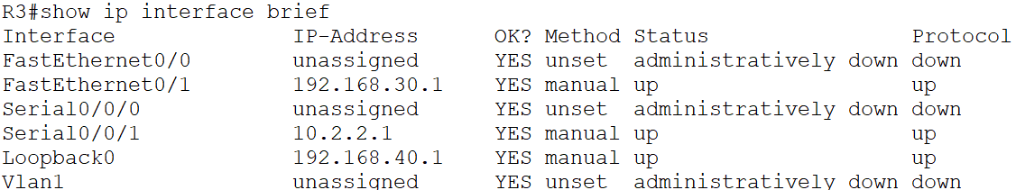

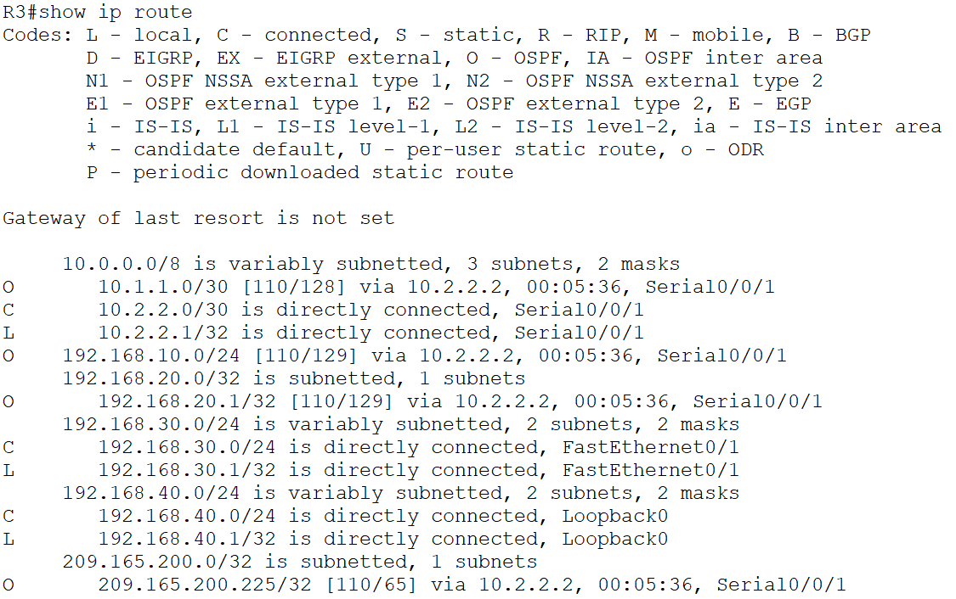

1. **Verify connectivity between devices using the ping utility, ping should be successful.**
   1. **PC-A to PC-C**

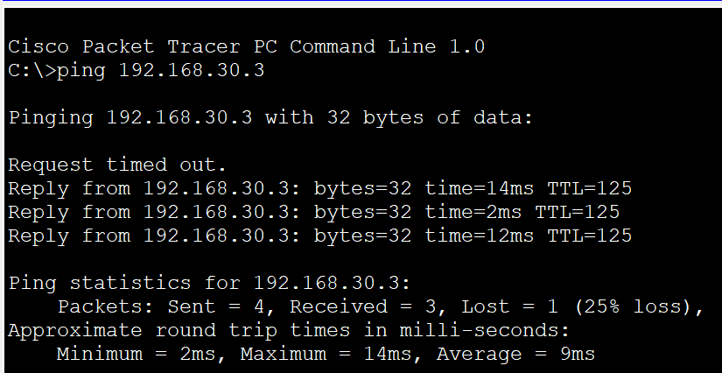

* 1. **PC-A to R3**

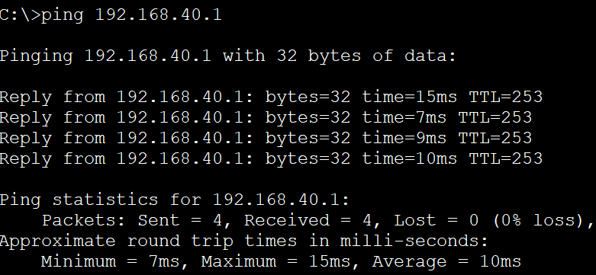

* 1. **R1 to PC-C**

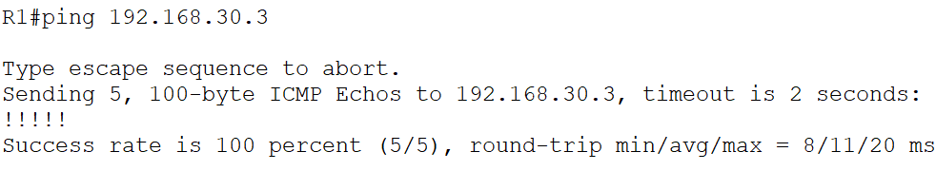

* 1. **R1 to R3**

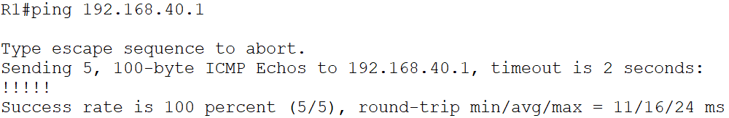

* 1. **PC-C to PC-A**

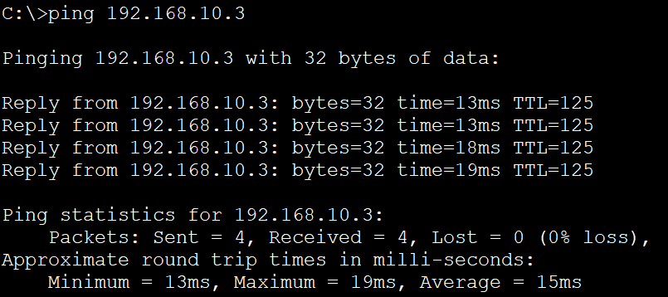

* 1. **PC-C to R1**

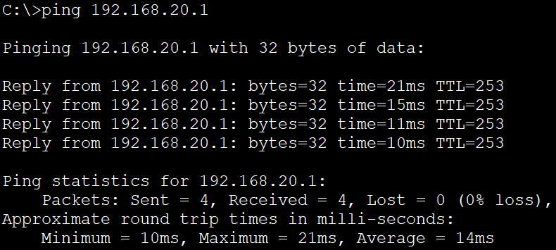

* 1. **R3 to PC-A**

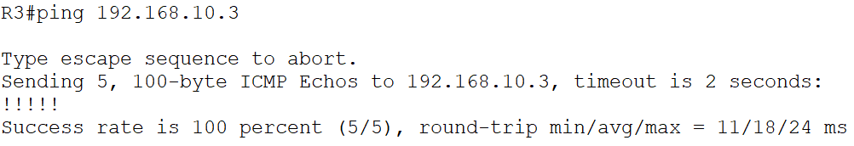

* 1. **R3 to R1**

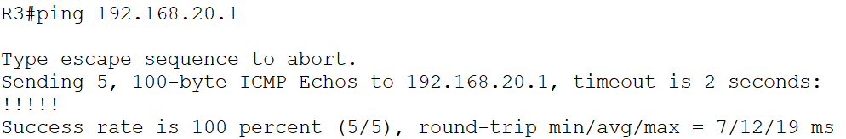

1. **Configure and Verify Standard Numbered and Named ACLs:**
   1. **Configure a numbered standard ACL that conforms to the following policy**

Allows traffic from all hosts on the 192.168.10.0/24 and 192.168.20.0/24 networks to access all hosts on the 192.168.30.0/24 network. The security policy also states that a deny any access control entry (ACE), also referred to as an ACL statement, should be present at the end of all ACLs.

1. Configure the numbered ACL on the appropriate router and applied to the appropriate interface in the proper direction.

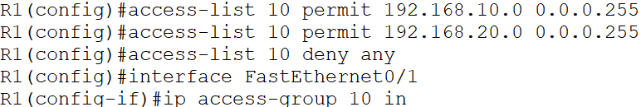

1. Verify the configured ACL.

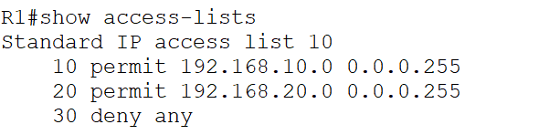

* 1. **Configure a named standard ACL that conforms to the following policy.**

Allow traffic from all hosts on the 192.168.40.0/24 network access to all hosts on the 192.168.10.0/24 network. Also, only allow host PC-C access to the 192.168.10.0/24 network. The name of this access list should be called BRANCH-OFFICE-POLICY.

* + 1. Configure the named ACL “BRANCH-OFFICE-POLICY” on the appropriate router and applied to the appropriate interface in the proper direction.

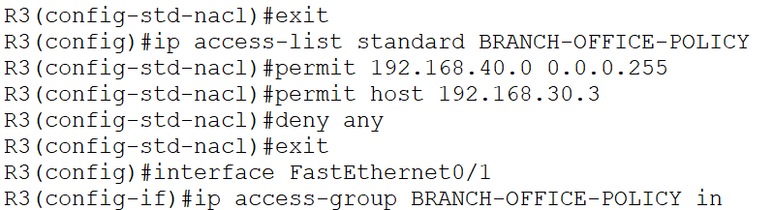

* + 1. Verify the configured ACL.

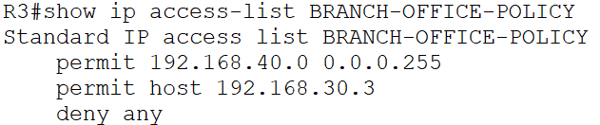

* + 1. Verify a named ACL: From the command prompt on PC-C, ping PC-A’s IP address.

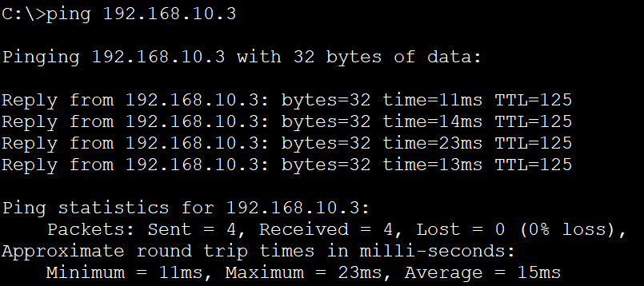

**Reflections**

1. **Following Cisco’s recommended best practices, on which router would you place numbered and named ACLs?**

* For numbered ACLs, place them on routers closer to the source of traffic.
* For named ACLs, place them on routers closer to the traffic destination.

1. **On which interfaces and in what directions, would you place the numbered and named ACLs?**
   * For named ACLs: Place them inbound on interfaces where traffic enters the router towards the destination network.
   * For numbered ACLs: Place them inbound on interfaces where traffic enters the router from the source networks.
2. **What wildcard mask would you use to allow all hosts on the 192.168.10.0/24 network to access the 192.168.30.0/24 network?**
   * To allow all hosts on the 192.168.10.0/24 network to access the 192.168.30.0/24 network, you would use the wildcard mask 0.0.0.255.
3. **Which command would you use to see all ACEs entirety of the access lists you have created?**
   * show access-lists